**CHAPTER ONE**

**INTRODUCTION**

## 1.1 BACKGROUND OF THE PROJECT

In the past, every electronic device has its own remote control which is built based on infrared and that means if I have eight devices then I will have as much as eight infrared based remote controls to operate them. These remotes work based on a principle known as line of sight (LOS) and that means one will have to directly face the remote to the device receiver to be able to issue commands. This feature of this remote is inconvenient, now suppose am in my room and wish to switch off home theatre at the sitting room? I will have to walk to where it is and press the required button on the remote.

In recent times people have become very lazy that they find it difficult to even get up and switch ON/OFF their devices which are plugged to power. They would prefer to sit at a place and control their devices with a single remote and that led to the invention of radio frequency remote controls. In developed countries home automation is a norm but developing countries like Nigeria are yet to adapt to this technology. Due to the inconvenience that comes with having lots of remote controls the radio frequency remote control was invented to control almost every device in the house thus eliminating the need of several infrared remotes.

## 1.2 PROBLEM STATEMENT The stress of moving from switch to switch to turn off devices from power is much and can be eliminated.

This project will proffer solution by integrating the ON/OFF switch of electronic devices in one remote so that the user can switch a device from any part of the house wirelessly provided he is not more than 100m from the receiver.

## 1.3 AIM AND OBJECTIVES

The aim of this project is to design and implement a radio frequency remote control which can switch ON/OFF 16 devices from a distance of 100m or less and then receive an ACK for a sent command.

For this aim to be achieved the following objectives are adopted:

* 1. Design of a 5V DC power supply unit required to power the circuit components on the transmitter and receiver side.
  2. Design of a 12V DC power supply unit required to power the transmitter module
  3. Design a keypad control circuit for the transmitter
  4. Design a display unit using Liquid Crystal Display (LCD 16 * 2) on the transmitter side.
  5. Design a switching circuit on the receiver side.
  6. Interface the designed circuits to a PIC16F877A microcontroller which serves as the central processing unit of the system by scanning for when a key is pressed and triggering transmission.
  7. Develop a software program in embedded C language that will control the processes of the microcontroller in transmitter and receiver side.
  8. Build a prototype to validate the functionality of the project.

## 1.4 SCOPE OF THE PROJECT

This project is limited to the development of a radio frequency remote control system which sends out data to the receiver to execute a command. When a button is pressed on the keypad the transmission process is initialized and selected data is encoded and sent to the receiver which decodes the data and takes action based on table of actions pre coded on the microcontroller. The transmitter side has an LCD where it displays what is going on in the transmitter. It informs the user on when to press a key, when the circuit is transmitting and when an acknowledgement is received. At the receiving side the devices are controlled by a logic determined by the microcontroller and switched through a relay. A single key can act as ON/OFF of a particular device.

This is achieved through a microcontroller (PIC16F877A) controlled by software program written in C language which serves as the central processing unit of the entire system.

## 1.5 SIGNIFICANCE OF THE STUDY

This project presents a system which provides solution to having so much remote control for each device and reduces stress of manually turning devices ON/OFF.

More so, by displaying the processes on an LCD the user can easily interact with the system and become familiar with the functionalities of the system.

# CHAPTER 2

**LITERATURE REVIEW**

An embedded system is a computer built to solve only a few very specific problems and is not easily changed. [1] An embedded system usually does not look like computer, often there is no keyboard or monitor but like a computer it has a processor and a software input and output.

A good way of managing electronic device power is by having the controls in a single remote on your hand. It reduces stress and helps conserve energy by ensuring that all the devices go off on power off and remain off until turned on by the remote.

## 2.1 OVERVIEW OF THIS PROJECT

### 2.1.1 RADIO FREQUENCY

Radio frequency (RF) is any of the electromagnetic wave that lie in the range extending from around 3KHz to 300GHz, which include those frequencies used for communications or radar signals. [2]

### 2.1.2 RADIO FREQUENCY MODULE

A Radio Frequency module is a small electronic device used to transmit and/or receive radio signals between two devices. These modules are widely used in electronic design owing to the complexity and difficulty of designing accurate radio circuitry. It uses Amplitude Shift Keying (ASK) modulation technique for its operation. It usually comes in pair’s i.e. a transmitter must have a corresponding receiver which operates at same frequency. The most common RF module is the TLP433/315 and RLP 433/315 where “TLP” indicates that it’s a transmitter and “RLP” indicates that it’s a receiver module. The number attached to the module indicates its frequency of operation in Mega Hertz. The radio signals radiated by the transmitter are modulated and travel a distance of about 100m at maximum voltage which is 12v in all directions penetrating walls and obstacles. The receiver which operates at 5v picks up these signals through its antenna and demodulates them.

### 2.1.3 REMOTE CONTROL TECHNOLOGY

A remote control system possesses the following features: encoding, synchronization, decoding, execution, error detection.

#### Encoding

It is the translation of a message that is easily understood. In this process, the sender uses verbal and non verbal language to send messages which he/she believes the receiver can understand. The symbols can be words and numbers, images, actions etc and it is important how these messages are encoded. [3]

In data communications the messages encoded are in the form of binary.

#### Decoding

The decoding of a message is how an audience member is able to understand and interpret the message. It is the process of interpretation and translation of coded information into comprehensible form. Effective communication is accomplished only when the message is received and understood in an intended way. [3]

#### Error detection

This is the detection of errors caused by noise or other impairments during transmission from transmission to receiver.

* **Synchronization**

This is the process of aligning the transmitter and receiver clock in such a way that data does not arrive out of order. This is achieved by accurate timing.

* **Error Correction**

This is the detection and correction of errors in a transmitted signal at the receiver end. These errors can be corrected either by retransmission of the data or Forward Error Correction (FEC) technique e.g. Hamming Code.

## 2.1.4 ENCODERS

These are integrated circuits that are capable of encoding 12 bit information which consists of N address bits and 12-N bits. [4]

## 2.1.5 DECODERS

These are integrated circuits that are capable of decoding 12 bit information which consists of N address bits and 12-N bits. [4]

## 2.1.6 PIC16F877A

This is a 40 pin microcontroller produced by microchip. It has 32 input/output pins 5 Analog to Digital Converters (ADC), 5 ports which are PORT A, PORT B, PORT C, PORT D, PORT E. it can operate with crystals whose values lie within 1-20MHZ and this crystal provides the clock pulses for the processor [5]. The microcontroller can be interfaced with almost any kind of device to achieve a goal. The way a system built with micro controller behaves depends on the control program written to drive it and the devices it is interfaced with.

## 2.1.7 SWITCHING CIRCUIT

This is where the ON/OFF implementation lies. It consists of 16 30A relays which are interfaced with the microcontroller through a transistor for effective switching. This circuit carries the load which is the electronic device to be controlled. A relay is an electromagnetic device which works based on principles of electromagnetic induction. It has a common (C), normally open (NO) and normally closed (NC) contact. When the relay is de-energized the contact is on the normally closed but when energized the contact is switched to normally open. This feature is exploited in automatically switching a device ON/OFF where a higher voltage is connected to the common and output taken from the normally open. Because the relay requires about 70mA current to be energized and the micro controller which is to energize the relay supplies only about 50mA a transistor is then connected to ensure that the relay gets enough current to energize.

## 2.1.8 DISPLAY CIRCUIT

The display circuit which consists of LCD and other discrete components interfaced with the microcontroller enables the user to follow instructions on what to do by displaying them on the screen. A 16 * 2 LCD is used so as to miniaturize the size of the transmitter. It has about 16 pins where 8 of them are data pins, two controls the backlight, three control the contrast, positive voltage supply and negative voltage supply [6]. The remaining three pins control how commands are issued to the LCD. The dimension 16 * 2 simply means that the screen is divided into two each of 16 pixels and can contain about 32 characters in all.

## 2.1.8 KEYPAD CIRCUIT

While the display unit instructs the user on what to do the keypad enables the user to issue commands as specified on the display using. A keypad is usually made up of monostable switches which are connected in an array or matrix form [7]. A continuous scan is run by the controller in other to detect when a key is pressed and which particular key is pressed so as to execute commands.

## 2.2 REVIEW OF RELATED LITERATURES

LIGO GEORGE [8] attempted to control devices by using the encoder and decoder IC (HT12E and HT12D) interfaced with the ASK RF module and a monostable switch to trigger the transmission when pressed. The interesting aspect of his work is the simplicity with which this was achieved. However he could only control 4 devices because of the limitations of the Encoder/Decoder pins. A better way would have been to interface it with microcontroller to expand the number of inputs and outputs on then transmitter and receiver respectively.

TARUN AGARWAL [9] in a project titled “RF Module-Transmitter & Receiver” developed a system with the same Encoder/Decoder IC but interfaced the encoder with a 20 pin Atmel Micro controller (AT89C2051). By incorporating the micro controller he made his work more flexible as he has more control on when a signal should be sent even without pressing a button. Although he achieved flexibility on the transmitter the receiver was still limited to four outputs as a result of the Decoder IC used.

Instructables.com [10] in a project implemented by R5SB named “Wireless Control of Robot using Arduino and RF Modules” developed a remote control for controlling the movement of a robot by rotating its tyres. He used arduino for the implementation thus eliminating the need for encoder and decoder IC’s. The control protocols ranging from encoding, decoding, synchronization, actuation etc was implemented on software using C language and Arduino libraries. The project is near perfect but cost ineffective considering the fact that you have to buy two arduino’s every time you want to embark on such project. These same protocols can be implemented using just any microcontroller thus saving cost.

KEVIN DARRAH [11] attempted to send temperature and humidity data from one room to another in other to be able to view and control room temperature. He achieved this by using RF modules interfaced with arduinos on the transmitter and receiver side. He implemented the Manchester encoding and filtering protocols in software in other to achieve an efficient communication and control system. The project is cost ineffective in the sense that one would need two arduino’s and a laptop or PC each time such a project is to be implemented. The Laptop is used to view the data sent over through the serial monitor of the arduino. A better approach would have been to use a single microcontroller rather than a whole arduino board and a mini liquid crystal display (LCD) say 16 * 2 to view the data sent over.

## 2.3 SUMMARY OF REVIEWS

The reviews were carried out so as to through more light on some of the similar works carried out by other researchers with respect to radio frequency remote control.

However, this project addresses some of the short comings of the related projects mentioned above. For instance, the work in [8] didn’t consider the fact that there could be more devices to control. This has been taken into account in this work by replacing the encoder/decoder IC with PIC16F877A microcontroller. The work in [11] didn’t consider cost so much by using whole Arduino board for a simple project. This has been taken into account in this work by replacing the arduino board with a single microcontroller and an LCD.

Moreover, this work has a special feature in the sense that it is a two way communication where the receiver can send an acknowledgment to the transmitter on reception of a signal indicating the state of the device.

# CHAPTER 3

**PROJECT METHODOLOGY AND SYSTEM ANALYSIS**

## 3.1 METHODOLOGY

Methodology is the systematic, theoretical analysis of the methods applied to a field of study. It comprises of theoretical analysis of the body of methods and principles associated with a branch of knowledge. Typically, it encompasses concepts such as philosophical or theoretical frame works, theoretical model, phases and quantitative or qualitative techniques. [12]

### 3.1.1 OUTLINE OF THE PROCESS

* **Subsystem identification**

The different sub systems are illustrated in the block diagrams below:

CONTROL UNIT

DISPLAY UNIT

KEYPAD CONTROL UNIT

RF TRANSMITTER & RECEIVER MODULE UNIT

POWER SUPPLY UNIT

**FIG 3.1 Block Diagram of a transmitter Remote Control System**

POWER SUPPLY UNIT

RF TRANSMITTER & RECEIVER MODULE UNIT

CONTROL UNIT

SWITCHING CIRCUIT

**FIG 3.2 Block Diagram of a Receiver Remote Control System**

* **Design/Development of subsystems**

The various subsystems are designed and simulated on Computer Aided Design (CAD) software called proteus. This software enable us model a system in other to ascertain its workability. The various circuit diagrams for the sub systems are shown below:

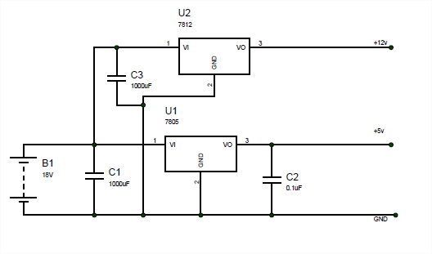

**FIG 3.3a Transmitter Power Supply unit**

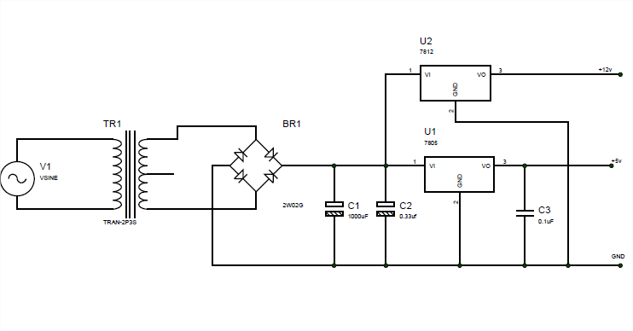

**FIG 3.3b Receiver Power Supply unit**

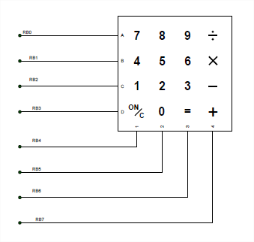

**FIG 3.4 Keypad Control unit**

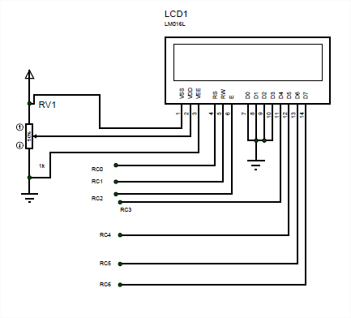

**FIG 3.5 Display unit**

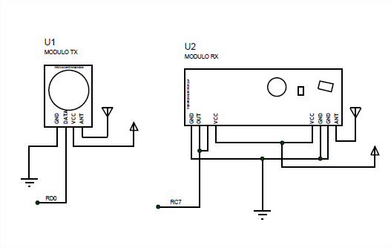

**FIG 3.6 RF Transmitter & Receiver Module Unit**

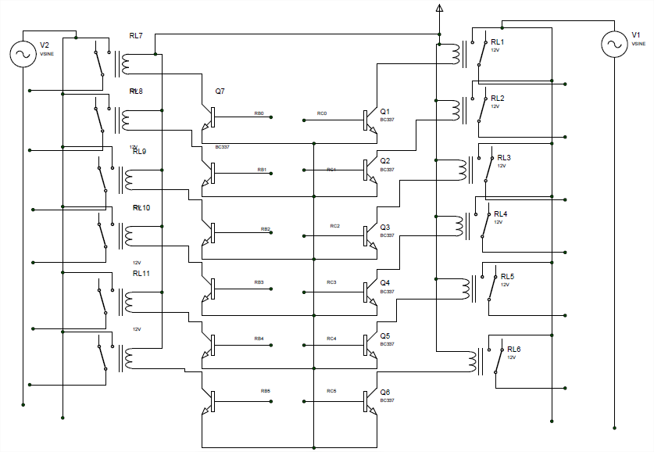

**FIG 3.7 Switching Circuit unit**

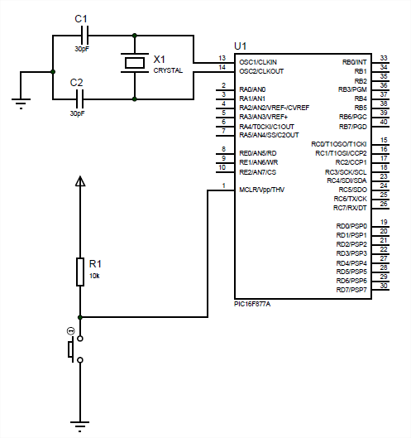

**FIG 3.8 Control unit**

* **Subsystem units integration**

Having simulated the individual subsystem units and upon proper functionality, the various units were integrated to validate the design as shown below:

